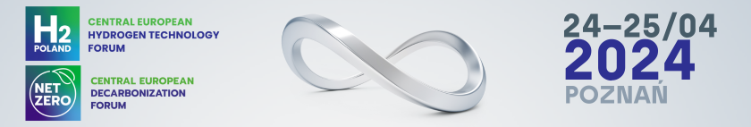

Press release 5/02/2024, Poznań

H2POLAND and NetZero Forum – decarbonization and hydrogen technologies on the European agenda

The goals set by the European Commission in recent years, related to environmental protection and preventing the growing climate crisis, mean that the issue of industrial decarbonization has become crucial for the entire Old Continent. We increasingly see that green approaches to production and consumption are not just a matter of ecology, but are becoming strategic goals for the entire economy. In this context, reducing carbon dioxide emissions and the development of zero- and low-emission technologies appear as catalysts for positive changes.

The multi-faceted nature of decarbonization translates into various benefits for the economy.
– New investments in low-emission solutions and innovative technologies will not only revolutionize industries, but also create new jobs and introduce higher quality standards. This is an opportunity for a more sustainable future and a key element in building a competitive advantage on the global market. Already in April, Poznań will host a fair devoted to hydrogen and decarbonization technologies - says Piotr Drozdowski, director of H2POLAND & NetZero Forum.

European Emissions Trading System
One of the key factors influencing the competitiveness of production is the ETS tax. The new regulations include: Carbon Border Adjustment Mechanism (CBAM), gradual withdrawal of free allowances in the Emissions Trading System (ETS), new regulations for road transport and buildings (ETS II) and the Social Climate Fund. The introduction of these mechanisms is a significant step for the EU in the fight against the global climate crisis.
Each of these mechanisms poses challenges to the European Union, especially in the context of their possible impact on the prices of energy and products manufactured in the EU, as well as on the overall competitiveness of certain industries. Therefore, the value of these regulations requires constant analysis and monitoring to find the right balance between ambitious climate goals and maintaining the competitiveness of enterprises.

Energy transformation
Subsequent topics of the Forum will be devoted to the RED III Directive, which entered into force in November 2023. Poland, like many other Member States, must adapt to its provisions, including: targets related to the share of renewable energy in overall energy consumption by 2030.
The role of hydrogen in the power system, costs of energy transformation, hydrogen storage, security of hydrogen infrastructure and certification in the hydrogen sector - these are the next topics of the Forum. Experts will present different perspectives on hydrogen transport, types of storage, safety aspects and challenges related to the certification of equipment and personnel.

Critical raw materials
Abandoning the use of fossil fuels cannot be a process that is intended to deprive humanity of fuels, energy or reduce the quality of life, but should take place in a planned, sustainable and safe manner. It is important to realize that such a transformation will require a significant increase in production capacity or extraction in areas that have not been crucial so far. New technologies for energy generation, transmission and storage, as well as the development of already mature ones, will increase the demand for a number of raw materials currently considered critical. – During the H2POLAND & NetZero Forum, we will present issues related to the CRM directive and challenges in the area of critical raw materials necessary for the energy transformation. We also want to draw attention to the fact that raw material security requires a significant increase in the share of recycling technologies in the supply chains of critical raw materials - says Robert E. Przekop, Ph.D., D.Sc., Prof. AMU.

Blue Deal
What is the role of water in the energy transformation? How the use of water resources and innovation can support sustainable development and the implementation of the goals of the Paris Agreement. The resulting panel discussion is expected to contribute to a better understanding of the opportunities offered by combining water and hydrogen resources, as well as help identify key areas requiring further research and investment. The Blue Deal is also an opportunity for regions to obtain financial resources to implement water management tasks.

The Central European Hydrogen Technologies Forum H2POLAND and the Central European Decarbonization Forum NetZero will be held at the Poznań International Fair on April 24-25, 2024.

www.h2poland.com.pl

